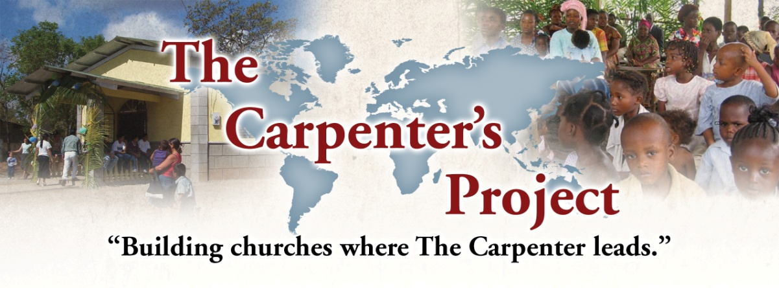

**A Global Ministry**

**for a**

**Global Need**

Facilitating church planting

and church growth

around the world

**Directors:**

John Conrad

[john@TheCarpentersProject.org](mailto:john@TheCarpentersProject.org)

Rodney Fitzsimmons

[Rodney@TheCarpentersProject.org](mailto:Rodney@TheCarentersProject.org)

Kerry Copeland

Vice-President

Keith Reedy

Missionary, Bibles for the Blind

Terre Haute, IN

Louis Schulz

Pastor, Palm Bay, FL

Dave Young

Evangelist, Pensacola, FL

**Advisory Board:**

Tom Burkett

Media Productions, Palm Bay, FL

Gary Click

Pastor, Fremont, OH

Scott Coombes

Pastor, Rosedale, IN

Matt Downs

Evangelist, Murfreesboro, TN

Rick Henry

Pastor, Franklin, IN

Wil Rice IV

Evangelist, Murfreesboro, TN

John Van Gelderen

Evangelist, Ann Arbor, MI

**Contact:**

c/o Hazelwood Baptist Church

PO Box 341

Clayton IN 46118

317-532-7079

[www.TheCarpentersProject.org](http://www.TheCarpentersProject.org)

Dear Friends in Christ, December 2016

**Haiti: Praises**

I had a great trip to Haiti in October and we rejoice in the Lord’s blessings:

* The pastors and churches are faithfully laboring in the harvest field. Souls are being saved and new converts are being baptized and discipled.
* I visited one of the new church plants on a Sunday morning and also built benches for the other new work started this year.
* Another trimester of the Berean Baptist Bible School began with 10 new students. The teaching is being done by 5 of our national pastors.
* Two new satellite Bible training centers will begin in January under the direction of the Bible school.

**Trip to Ivory Coast: December 1-14**

John and I had planned to visit Ethiopia but political unrest forced us to postpone this trip until next year. So we visited the works we help in the Ivory Coast instead. You can read about this fruitful visit in this month’s TCP newsletter.

**Please pray for these upcoming trips:**

* **Haiti: January 4-24**. During this trip the following activities are planned: Bible conference, preaching in churches, meeting with pastors, new trimester of courses in Bible school with new student enrollment, Bible school graduation, four Gospel film showings, and construction of a building at the Grand Rac church for children’s ministries.
* **Myanmar: January 31-February 14**. This will be my first visit to this field where TCP is helping national church planters.
* **Philippines: March 6-21**. During this trip I will be teaching nationals in 2 Bible conferences, preaching in several churches, and speaking at the Bible school graduation.
* When in the States January through March, we will be traveling to churches in Indiana, Illinois, and Alabama to present the ministry.

Thank you for your faithful prayers and support of this ministry.

Have a joyous Christmas and a blessed New Year.

***Rodney & Cathy***