Serving in East Hartford Since 1983 December 2015
The Connecticut Lanyon Family Homeland Est 1988
Greetings from Connecticut
Our Amazing American Heritage Is Rediscovered...
As we study it each week and see it’s durability and resiliency rise to new heights!

Dear Beloved Family,
With inner joy abounding we realize we are among all peoples of the world most singly blessed as Americans. We hope that you will not let a lot of negativity surfacing today obscure the deep down faith and strength of average Americans making the most out of life today.
Psa 61:3-5 For You have been a shelter for me, A strong tower from the enemy. (4) I will abide in Your tabernacle forever; I will trust in the shelter of Your wings. Selah (5) For You, O God, have heard my vows; You have given me the heritage of those who fear Your name.
Each year we have so much to be thankful for, and the ‘just- past’ thanksgiving season is the perfect back drop for the beautiful Christmas season before us all. Let us drink in it’s fullness and share it around us all.
Several years ago Pat put together a tract that reminds us of this great gift we see at Christmas:
Romans 6:23b “The Gift of God is ETERNAL LIFE through Jesus Christ our Lord.” Note these three brief points, then if you can, see it in full online:
1. You get it for free! (No co$t!)
2. When you give it away you cannot lose it; yea, by giving it away, it becomes an enrichment to your own soul!
3. The receiver of your gift derives the same benefit by accepting and giving it away again! You benefit as well again! So Give Freely Friends!
http://aprayernotebook.net/apn/tracts/most_amazing_gift_ever_given.html
http://aprayernotebook.ne t/merrychristmas

Pat’s Tracts Reprinted for Third Time!
http://aprayernotebook.net/after-believing
In August, after seeing 2008 tract supplies dwindling, Pat worked up a resized-for-economy pair of the most useful tracts written and we paid to reprint them both: A Simple Bible Study on Believing, and After You Believe, Please see these online as well, if not enclosed herein.

Saints Depart Us in 2015
The following of our friends and ‘adopted’ family have departed, and we rejoice that most were fruitful believers we believe have gone to a great reward from faithful service.
✞ Dave Christenson,
Nov 2014 Heart attack; Dave was a ‘76 BJU grad, and long term missionary to Mexico.
✞ Pam LaCapruccia,
March, 0215 Pam was faithful wife of Kurt LaCapruccia who now Pastors in PA, formerly in TBC, and faithful Pastor in CT
✞ Barbie Williams,
June 8, 2015 heart attack, Christine’s Bahamas’ friend was Professor @ Eastern CT State, and instructor to faculty, a sudden and very shocking loss to ECSU
✞ Marge Grynkiewicz,
Oct 5, 2015 – TBC member, dearly loved by Christine for many years in our Church
✞ Rachael Cooney ,
April 8 – Pat’s Carpet Cleaning Client, was then Resident and Sunday History Class attender at Riverside HCC.
✞ Irene Gardner,
– was Resident and Sunday History Class attender at Riverside Health Care Center.
✞ Claudia Domrese
November, 2015– was former TBC member and co-worker with Chris on 1 account, also suddenly taken and greatly missed.

Our Health Issues
Pat’s Laryngopharyngeal or ‘Silent’ Reflux, is worse now. He first saw a sleep specialist and did a home sleep study. There was enough evidence to order and purchase a CPAP. Research has indicated “Airway Reflux” as it is now called can affect this as well. The machine seemed uncontrollable for now. Reflux has now migrated beyond the vocal cords making a sore throat. He is 25+ lbs off his optimum weight. “Dropping Acid” diet is essential but to heal he realizes probably more will be needed soon to truly heal after suffering from 1983-2012. A documentary has helped us a lot recently, though not diagnosed: www.thetruthaboutcancer.com.http://www.voiceinstituteofnewyork.com

Newer Caravan after 12yr
We made the choice to replace our Grand Caravan from 2003 with a 2014 version in August. The sales rep was a pleasure to us.

More ‘People’ of Ministry
God has brought several people for us to serve in various ways and they have been a great blessing to us as we have sough to be to them.

Rose Fernandez –
Carpet Cleaning Client with spiritual interest.

Walter Grisevich –
Local nearby resident who invites us over each Monday for home cooking by Chris.

Maria Troulas –
Sunday PM TBC attender who has Chris over each Friday to share faith together. She also provides our family with her home cooking.

David Edwin Computer Wiz
Has become the greatest blessing to us physically by cleaning for us while his brother is finishing up school. The sincere desire to help by giving to all others he knows is amazing to us. When he is not doing taekwondo or cleaning you will find him doing his real vocational love: COMPUTER TECHNICAL SERVICE! www.glorycarpetcleaning.com/ david/computers.htm
Pat & Christine,@ TBC Harv.Banq.

Joseph’s PCC Graduation
Pensacola Christian College has been a great challenge for Joseph, and he is completing his Business Management major’s highest level courses and should be back in CT about Dec 20. His Aunt Vicki has volunteered to help him return home this month, for which we are very grateful. Joseph greatly anticipates his May, 2016 Commencement.

Christine – Our Queen
Chris has not changed her loyal and faithful testimony as one of the most beloved people in our church and her Sunday Class, our family, our neighbors, and our nursing home residents. She blesses everyone she meets with unfeigned heartfelt love that can be felt in person. Any who learn her testimony have a holy envy for the great choices she has and continues to make.
The CTLanyons Homeland Online:
http://aprayernotebook.net/homeland/

Conclusion
Let us pray for a renewed America. 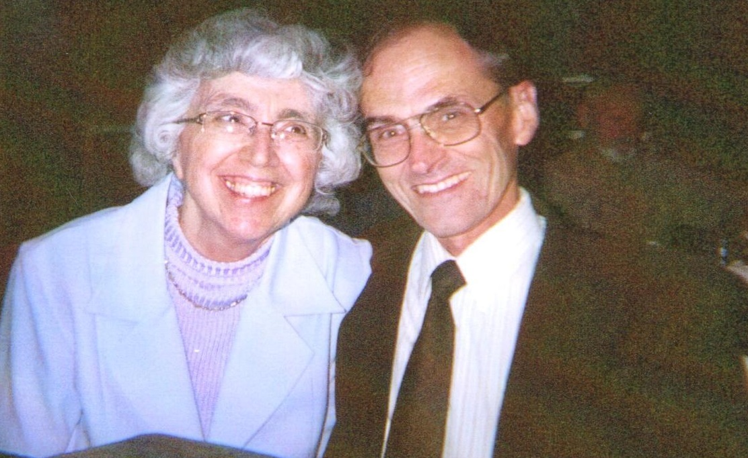

Pat Christine David & Joseph

Lanyon

47 Long Hill Street

East Hartford, CT 06108-1436
860-528-7205 c/txt :860-655-9000
David on a long bike hike.

Joseph at Barbie’s House.

