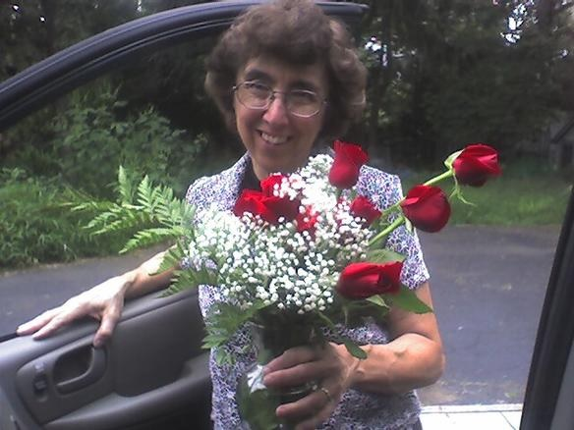
=====Christine E. Lanyon, 74, passed away after a brief battle with an aggressive cranial tumor on November 6, 2023, with her family at her side. Born on January 20, 1949, Christine’s legacy outlives her life. Her queenly cards ministry showcased her generous heart and genuine concern for others. Christine was a virtuous woman in every aspect of her life. She attended Tennessee Temple graduated and as a BIMI missionary taught 2nd Grade for 12 years in Nassau Christian Academy, Bahamas, then for 3 years served under a Pastor in Providentiales! In 1988 she married Charles Lanyon and served in Truth Baptist Church for 35 years.

Christine is survived by her devoted husband C. Patrick and her cherished sons David Edwin and Joseph Patrick. She is also survived by her sister Mary (Wise) Davis, nephew Arthur Davis, Jr., niece Debra Ames, nephews Darien and Johnathan Davis, nephew Nathan Ames, niece Kathleen (Davis) Barteck, cousins Fred Nassif and Barbara Gale (Nassif) Smith, and nephews Michael and Joseph Barteck Jr. She is predeceased by her father and mother Cecil and Mary Wise, brother-in-law Arthur Davis, sister Victoria Wise, and niece Jennifer Lynn Davis. Christine also leaves behind all her brothers and sisters in Christ at Truth Baptist Church and beyond whom she loved dearly.

=====A Memorial Service to celebrate her life will be held at Truth Baptist Church on Saturday, November 18, 2023, at 10:30 AM followed by a luncheon in the gymnasium.
=====In lieu of flowers, the family requests that donations be sent to Mansfield Baptist Temple in Ohio, designated towards the ministry of Christine’s sister, Mary Davis, an evangelist in Haiti. Donations can be made online at MBT.org or sent by mail to Mansfield Baptist Temple, 752 North Stewart Road, Mansfield, OH 44905.

